1.EXCEL TO OLE DB (DELIVERY TRUCK DATA) PROCESS:

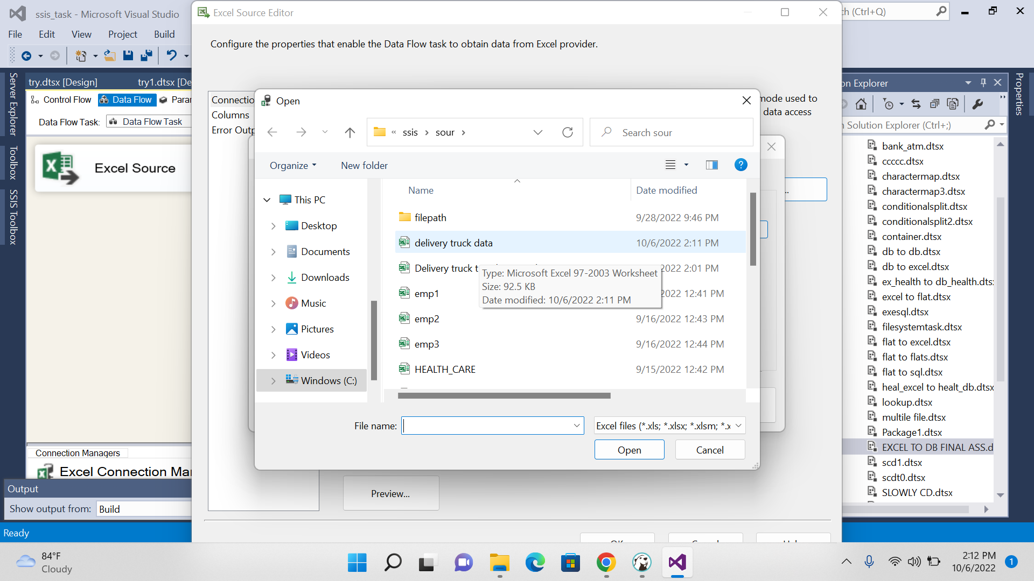

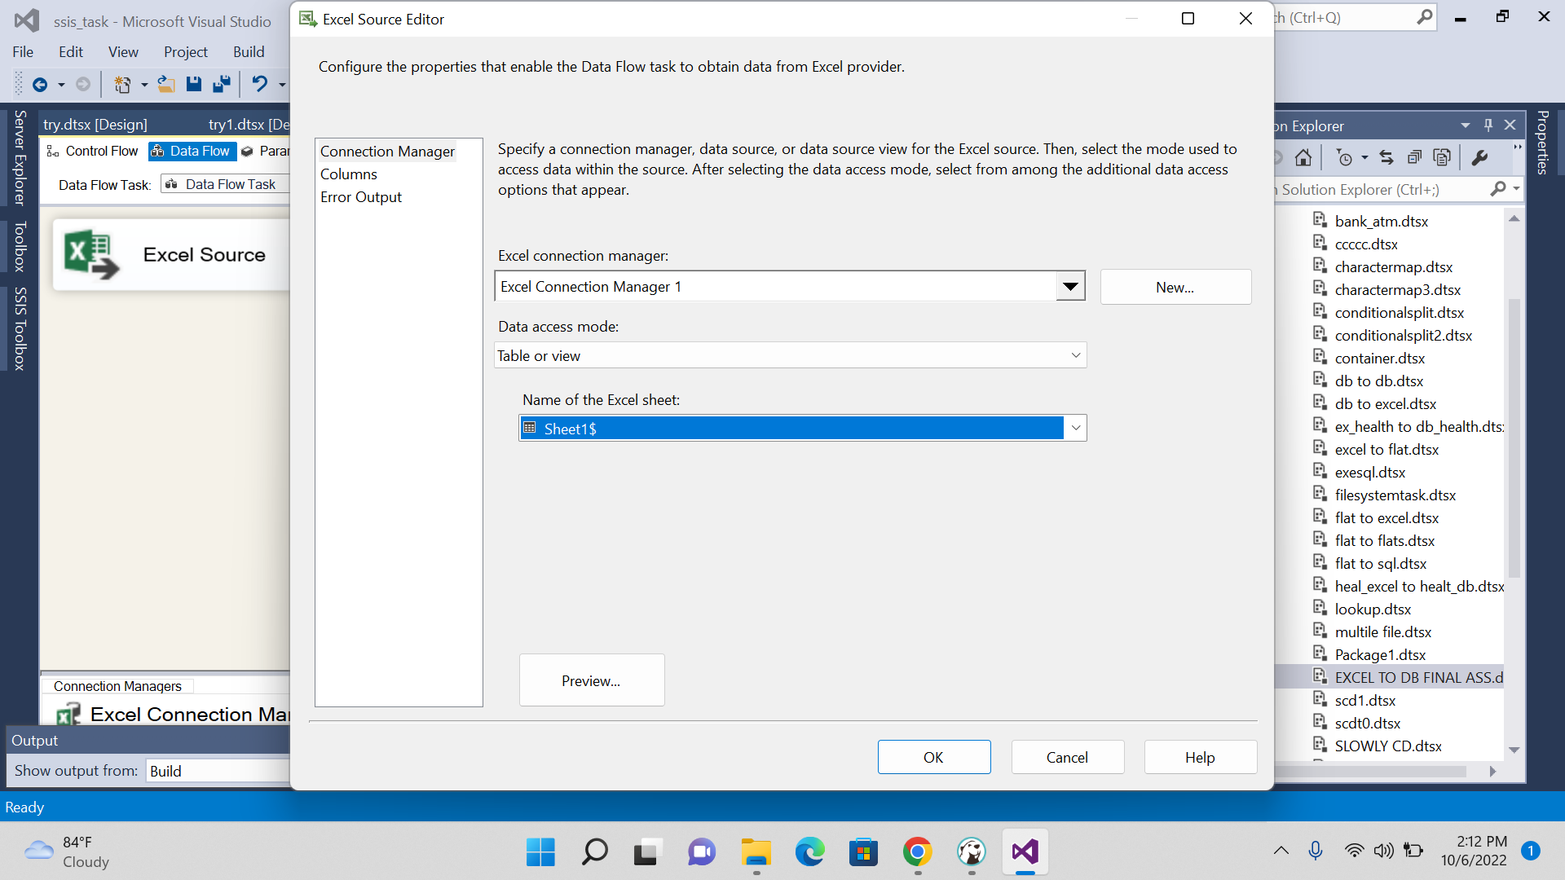

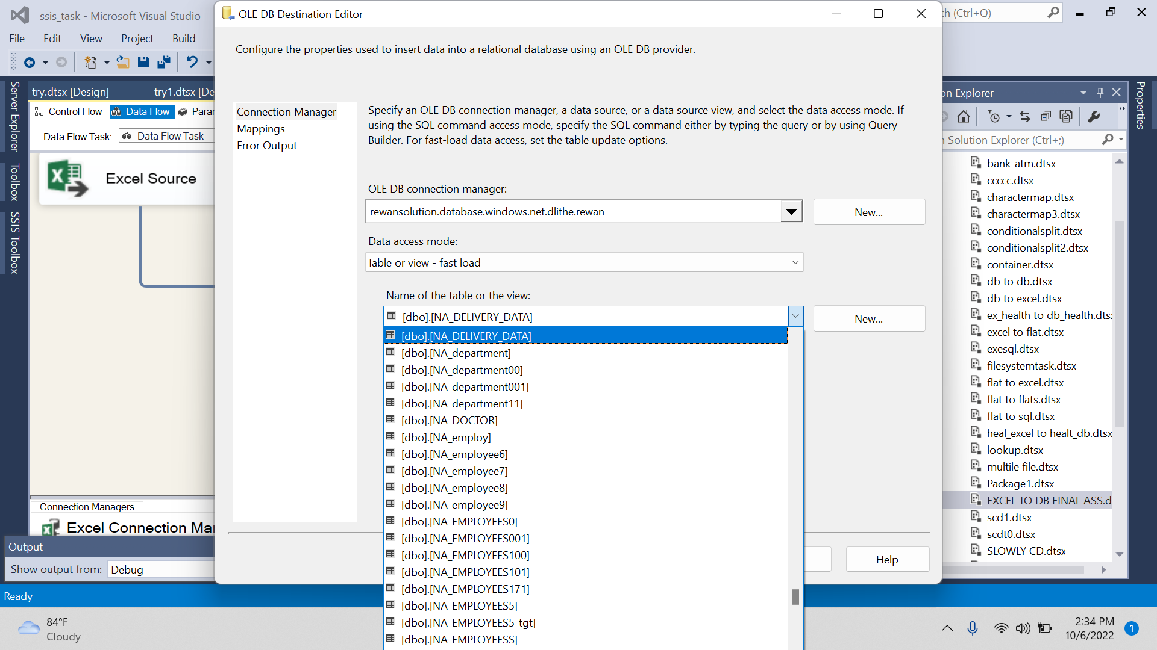

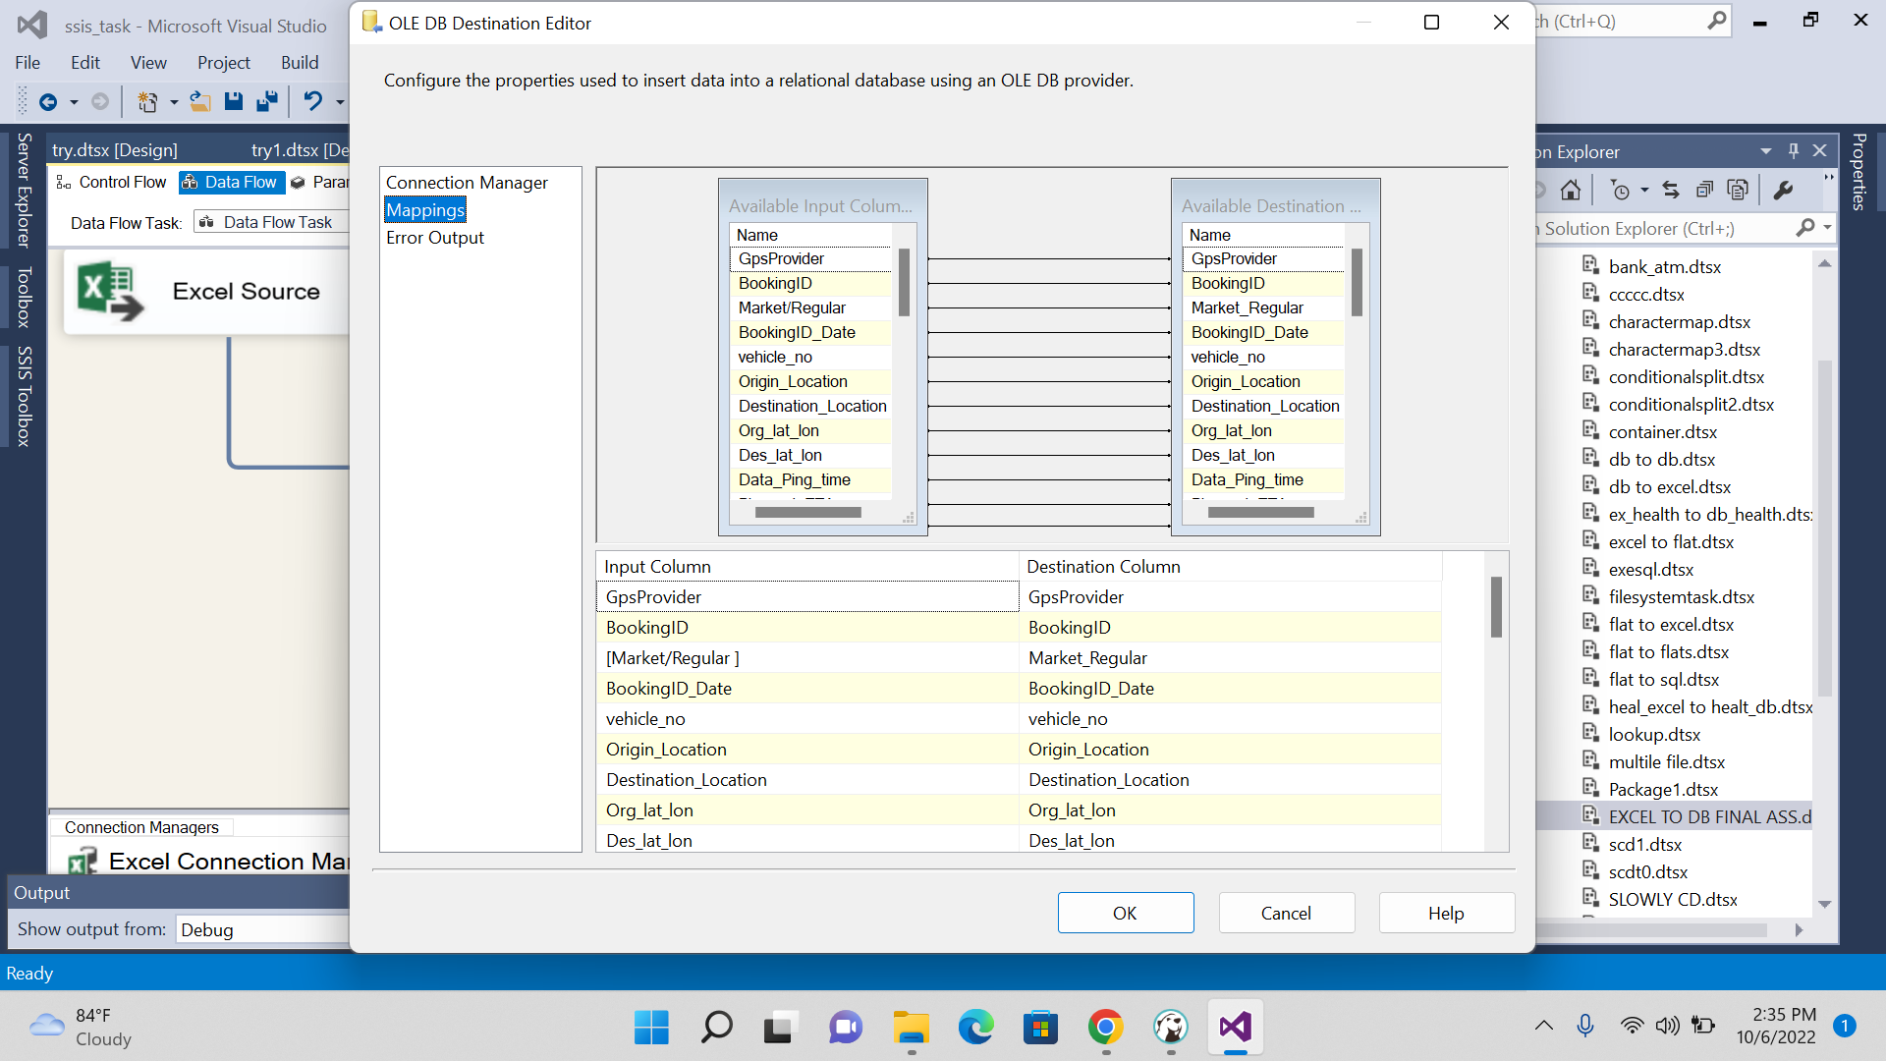

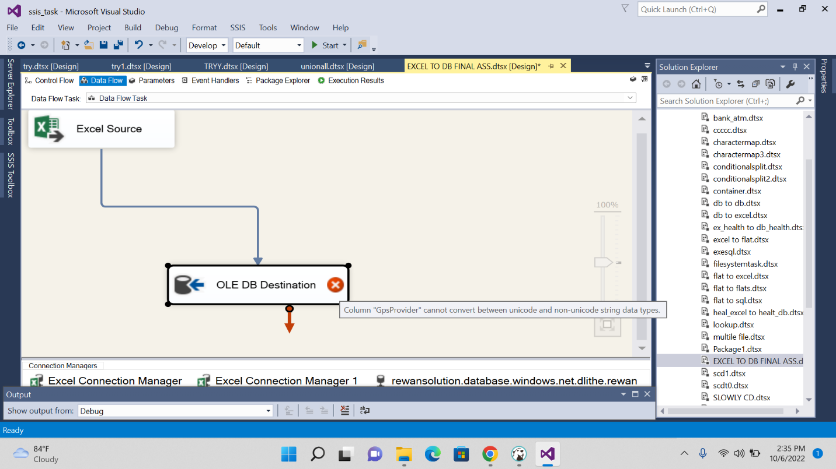

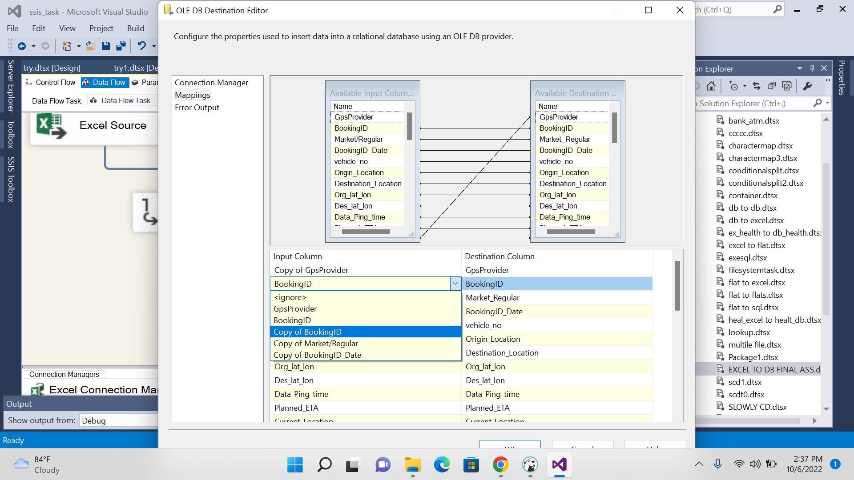

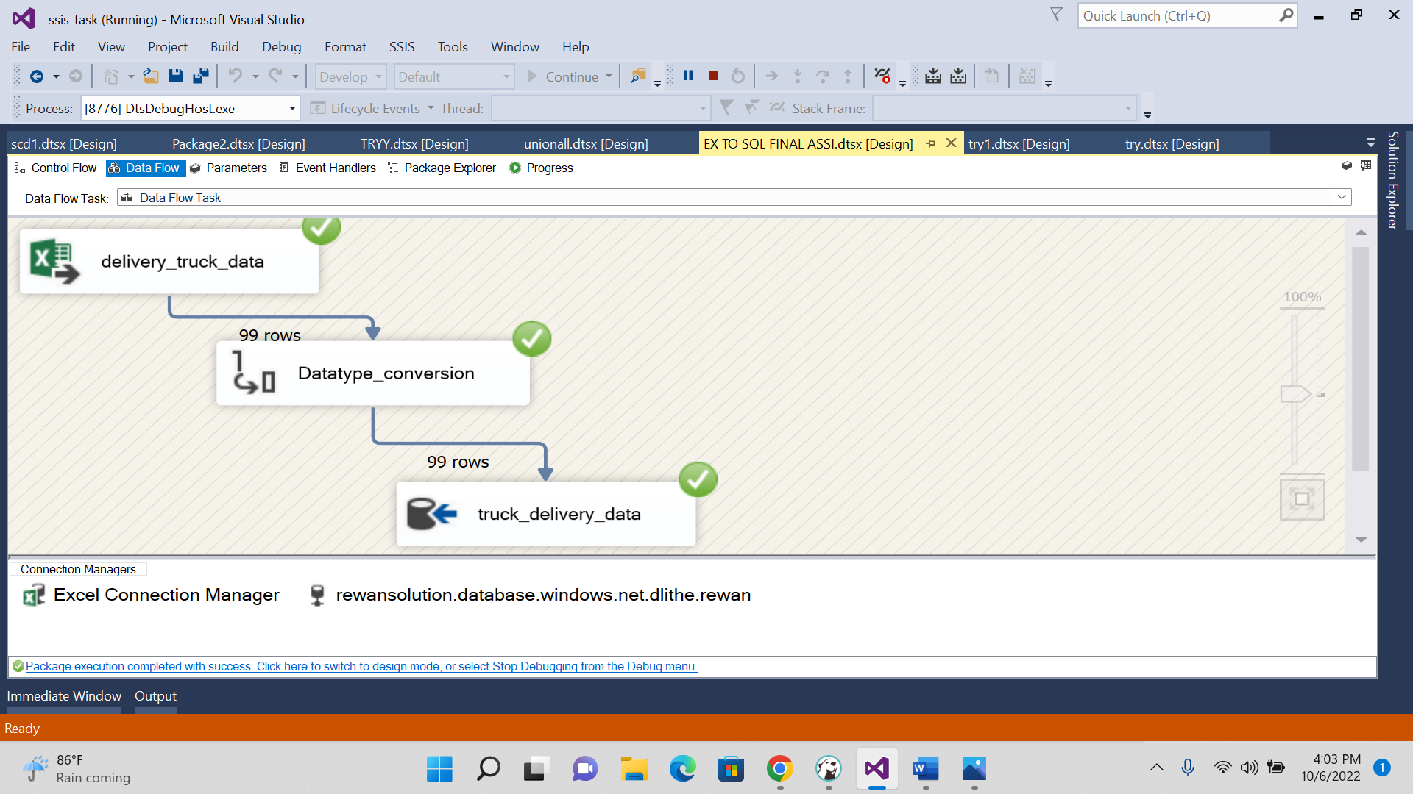

2. SLOWLY CHANGING DIMENSION (TYPE 1) PROCESS:

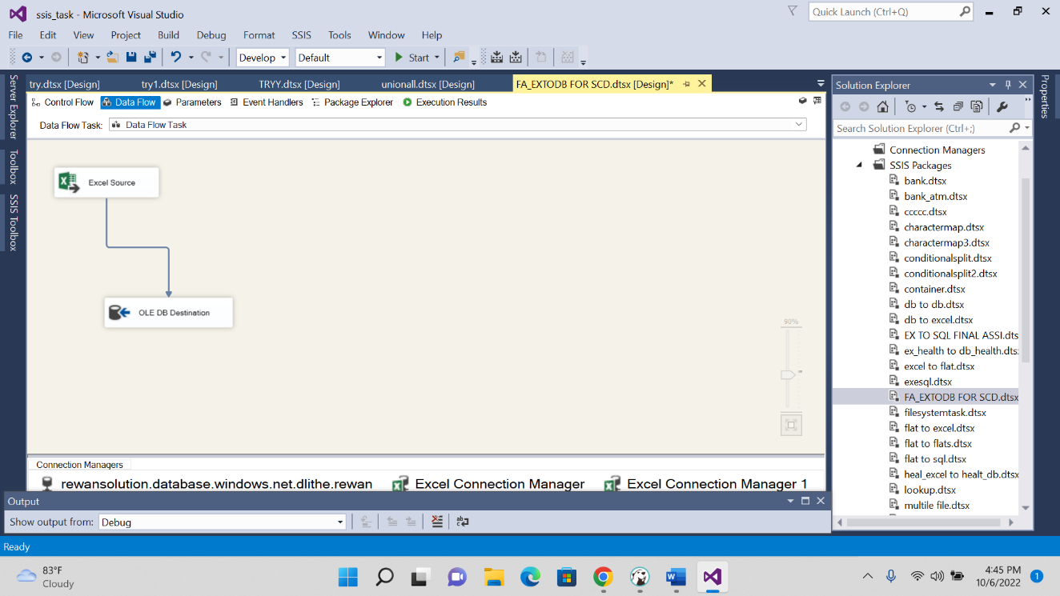

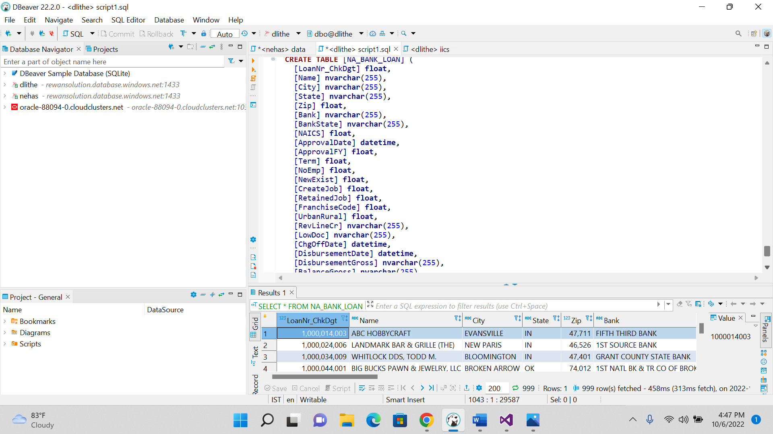

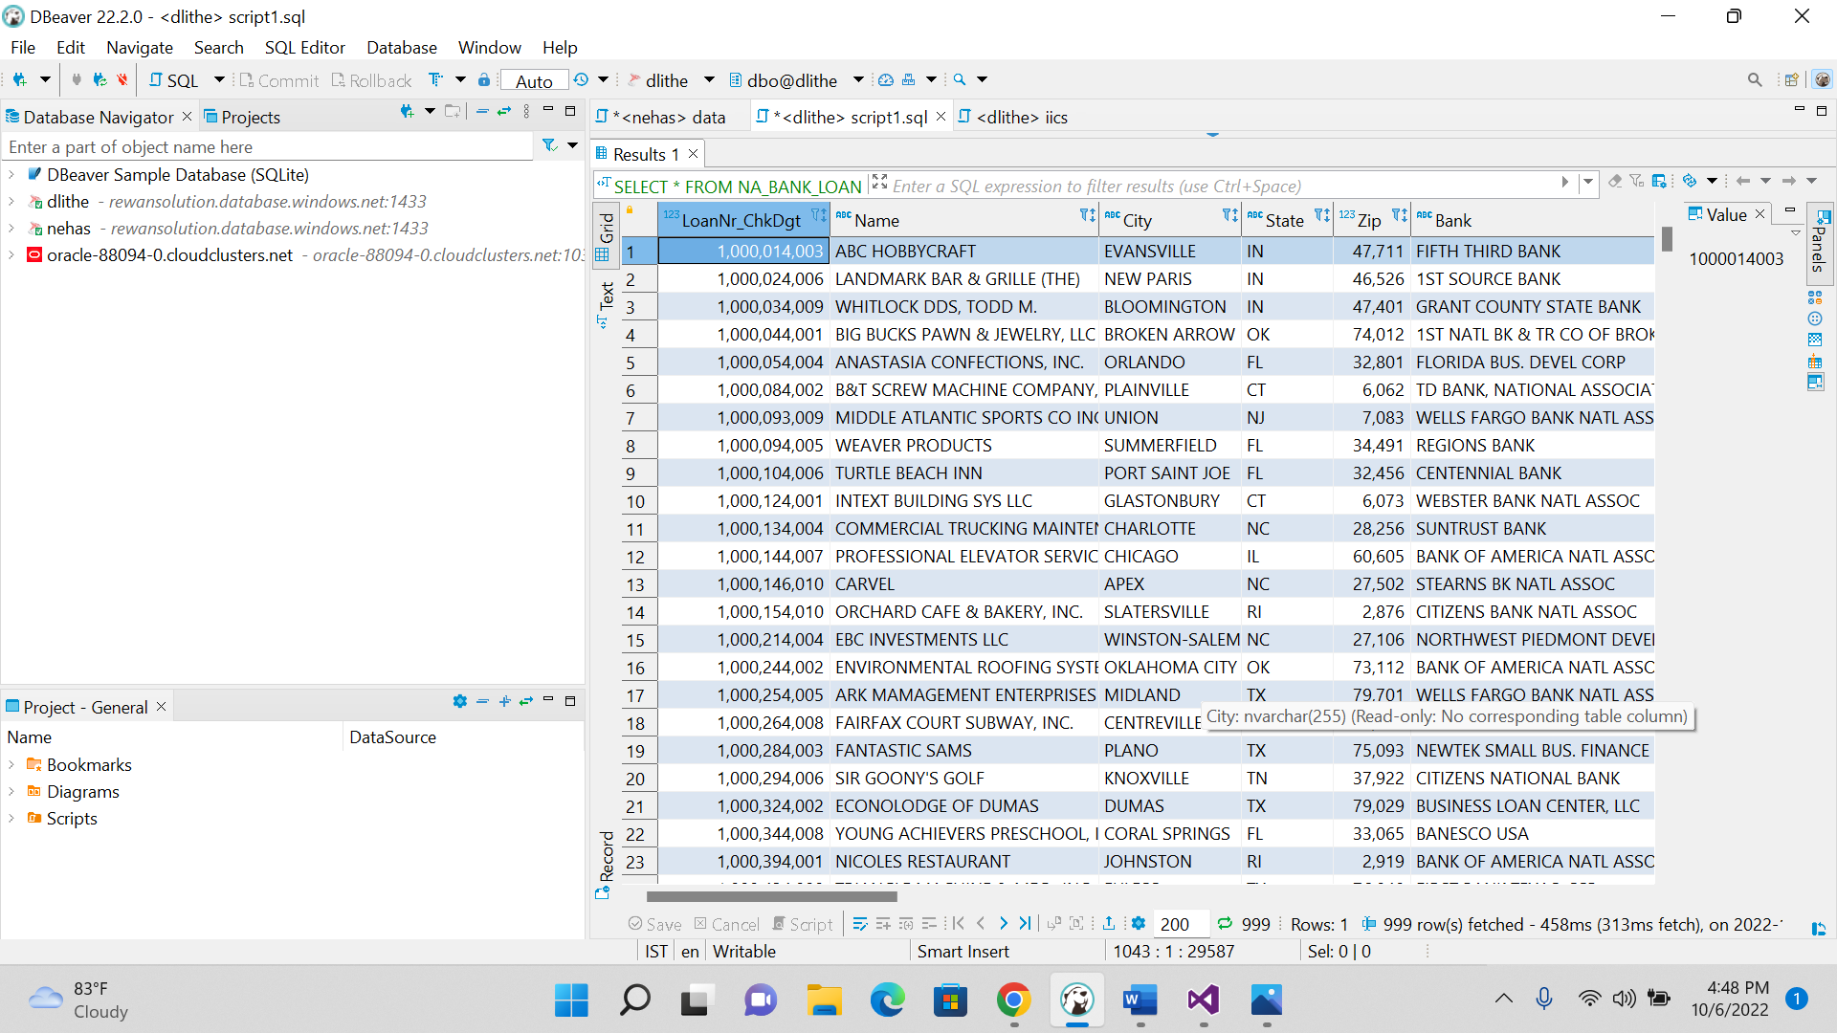

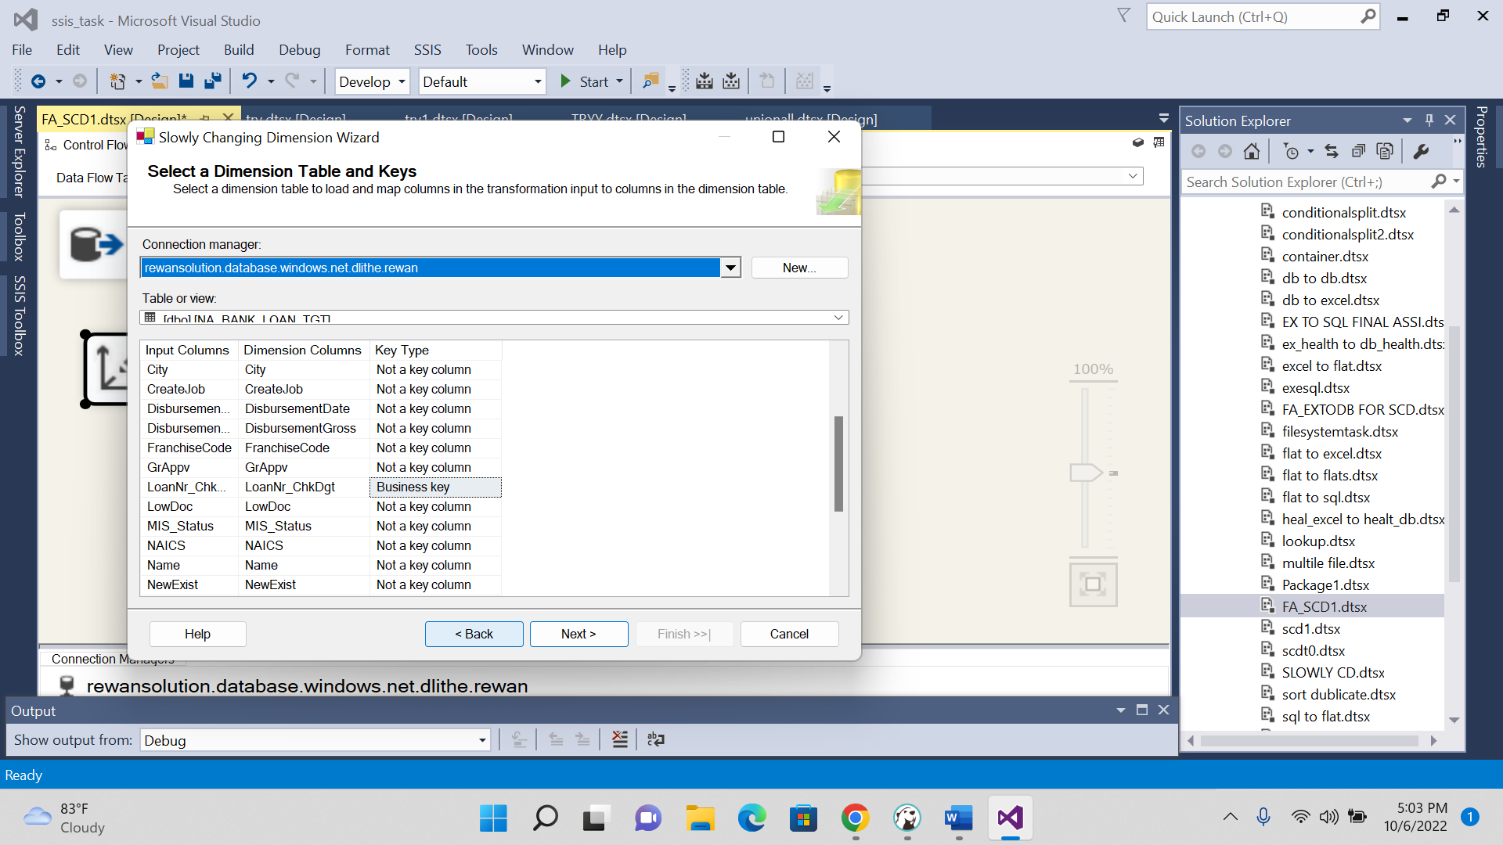

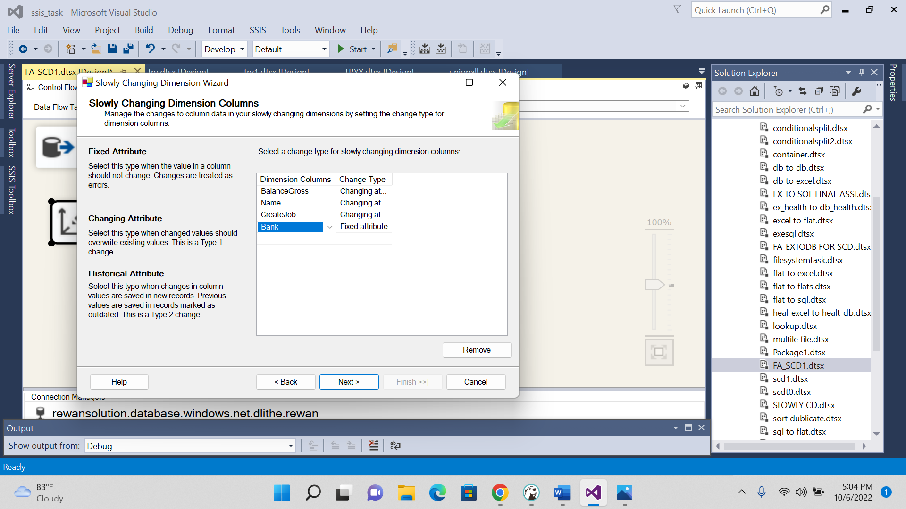

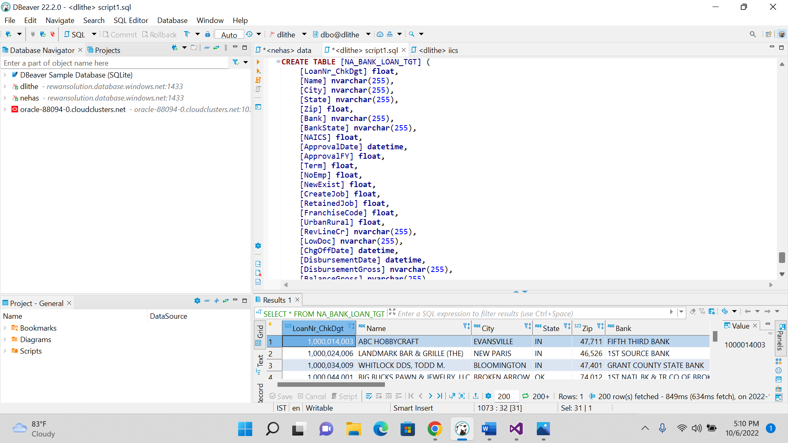

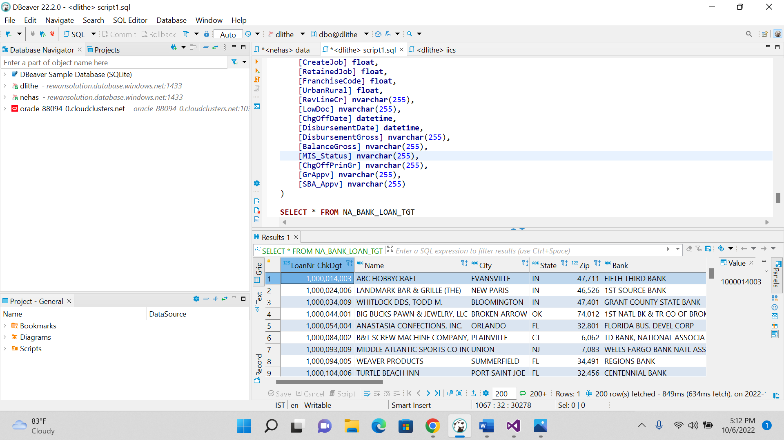

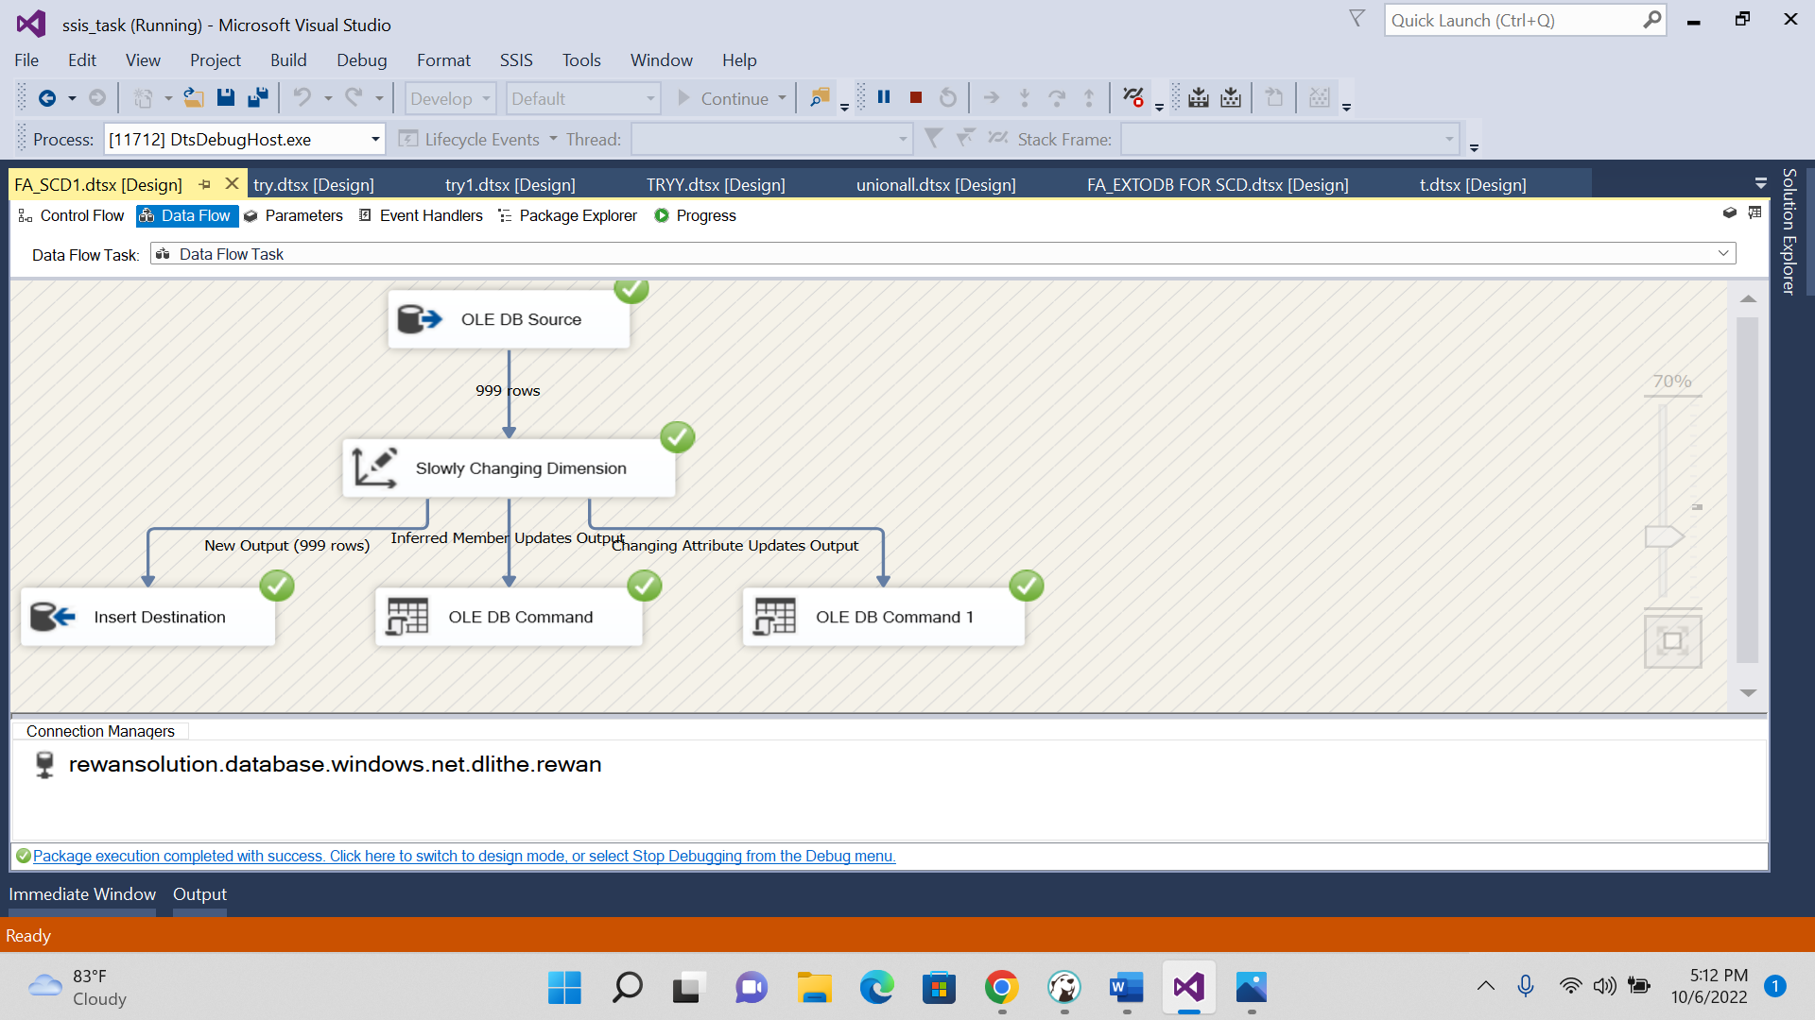

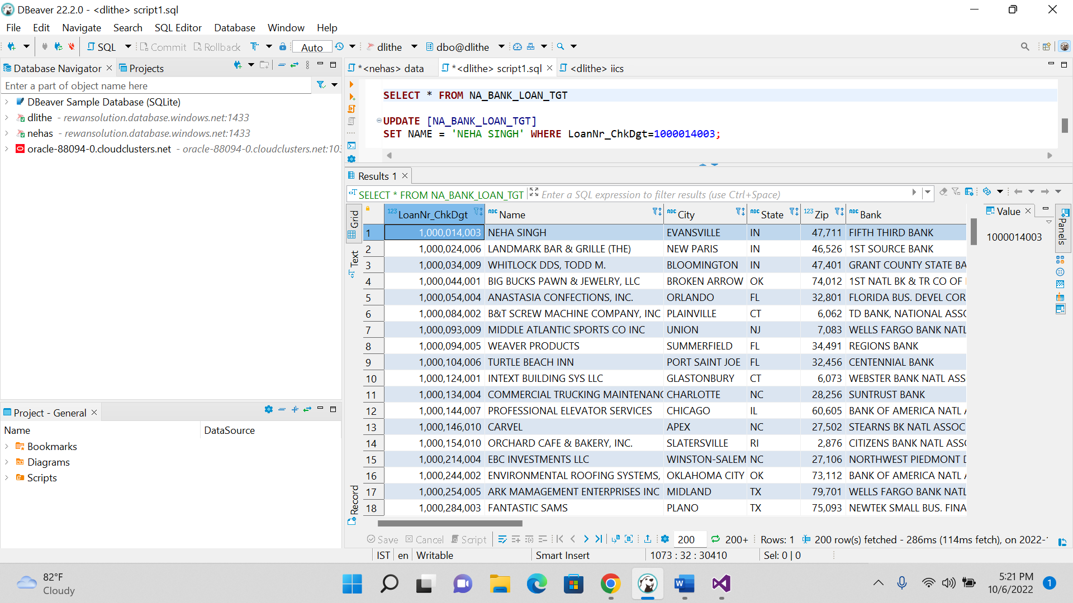

SCD TYPE 2(PROCESS):

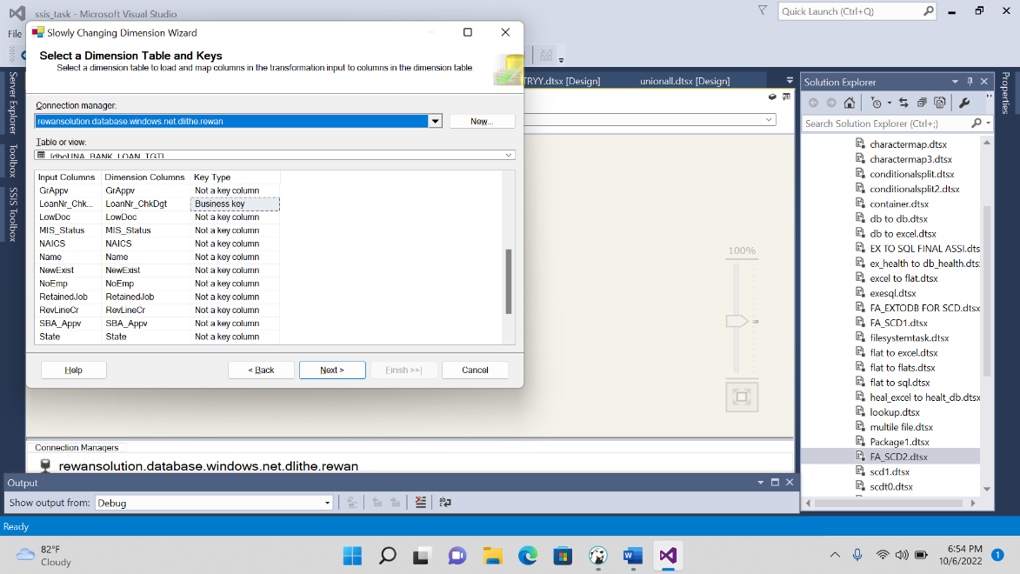

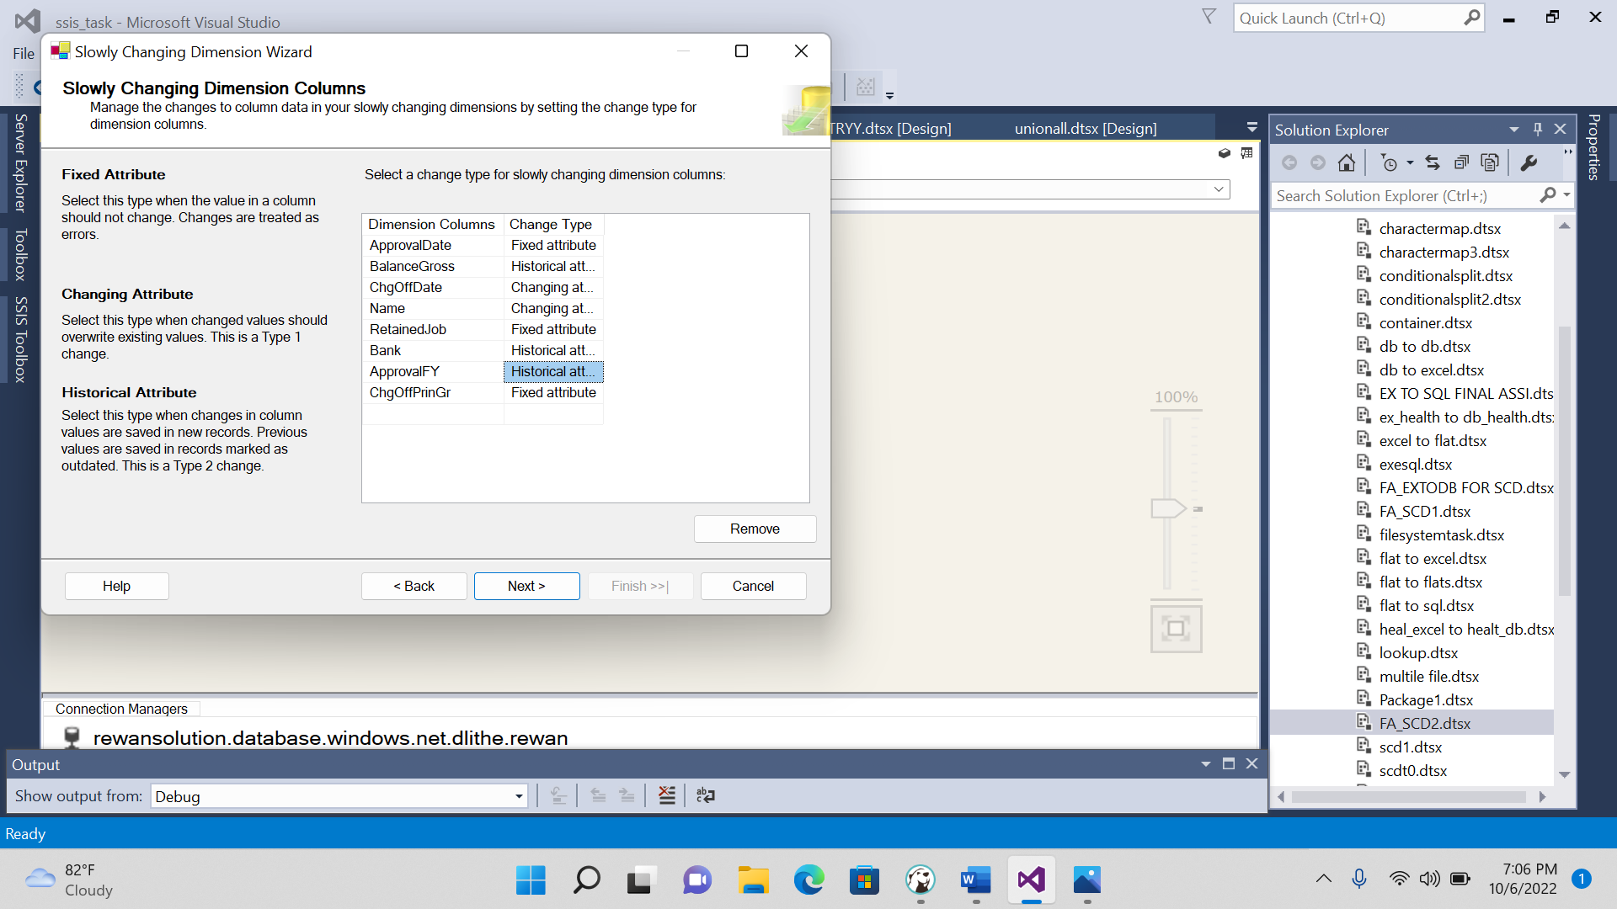

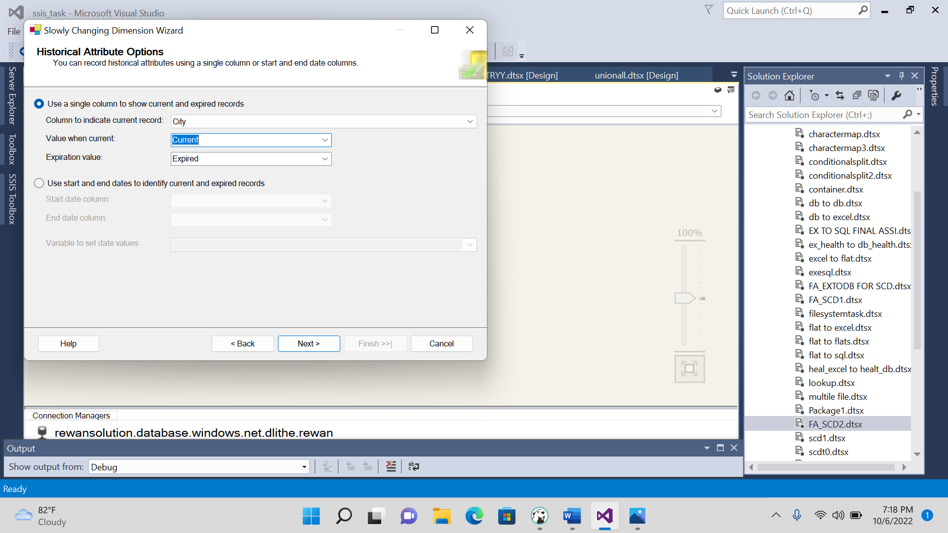

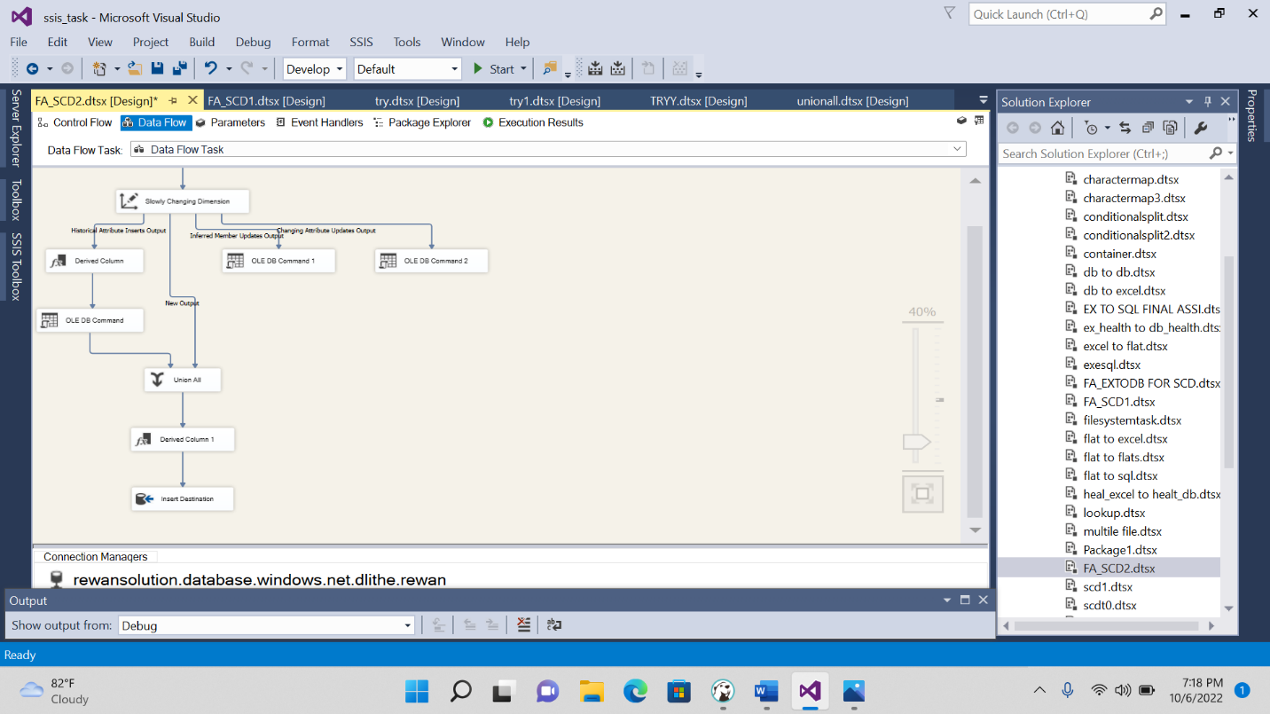

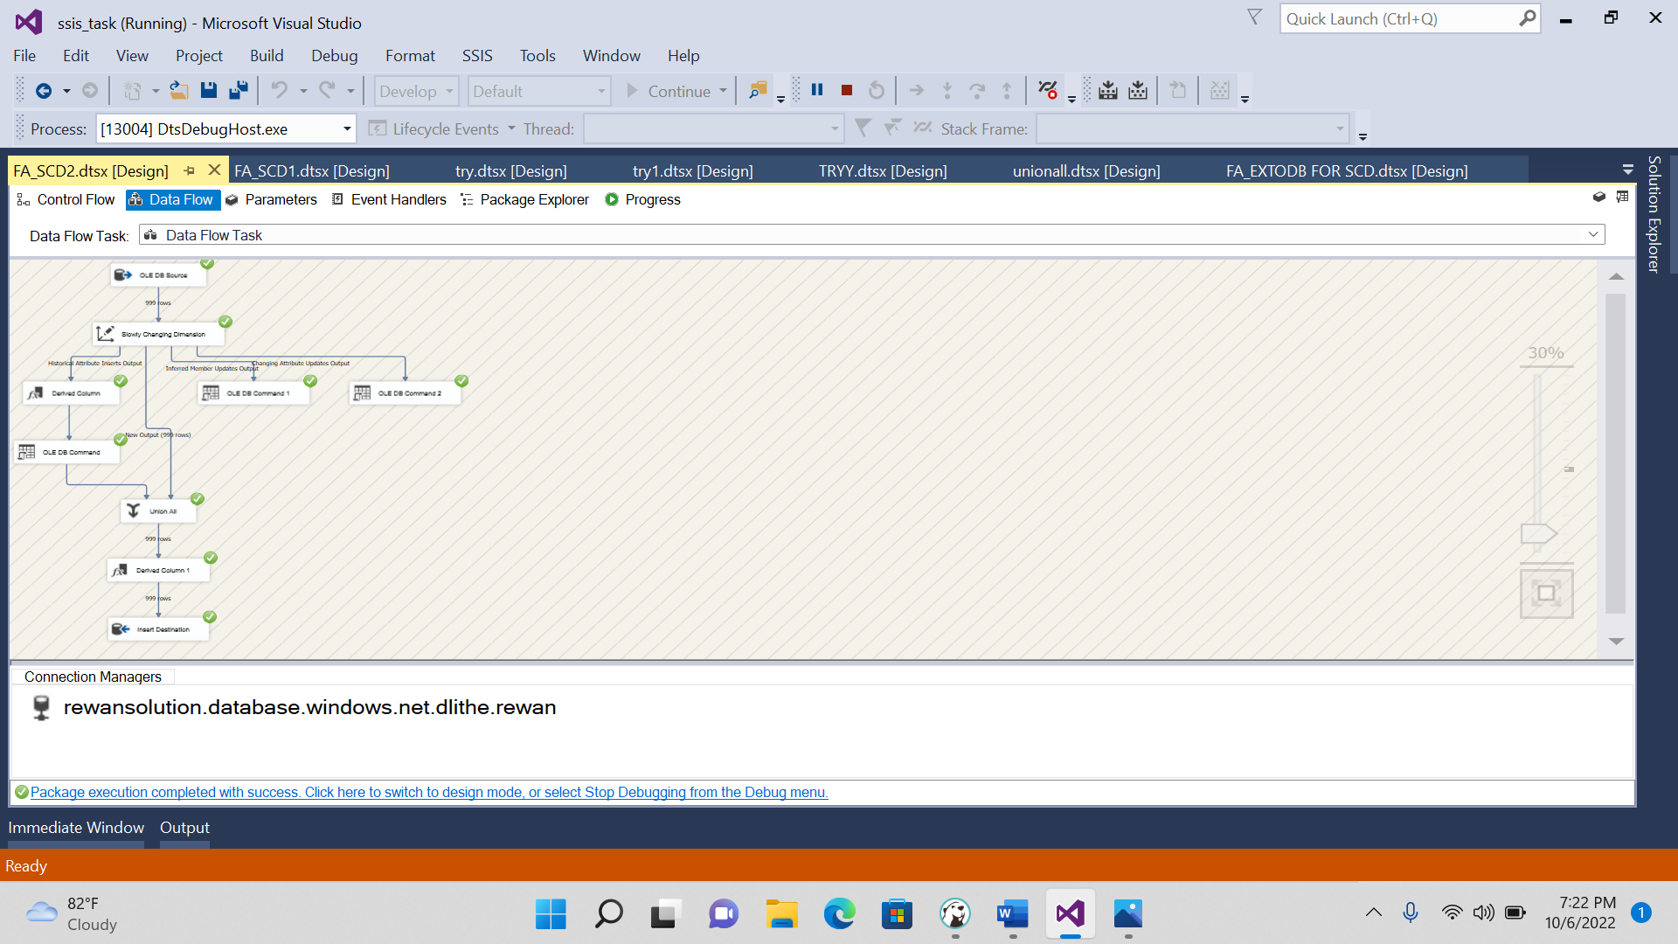

2.SCD TYPE2:

CINEMA DATA SET

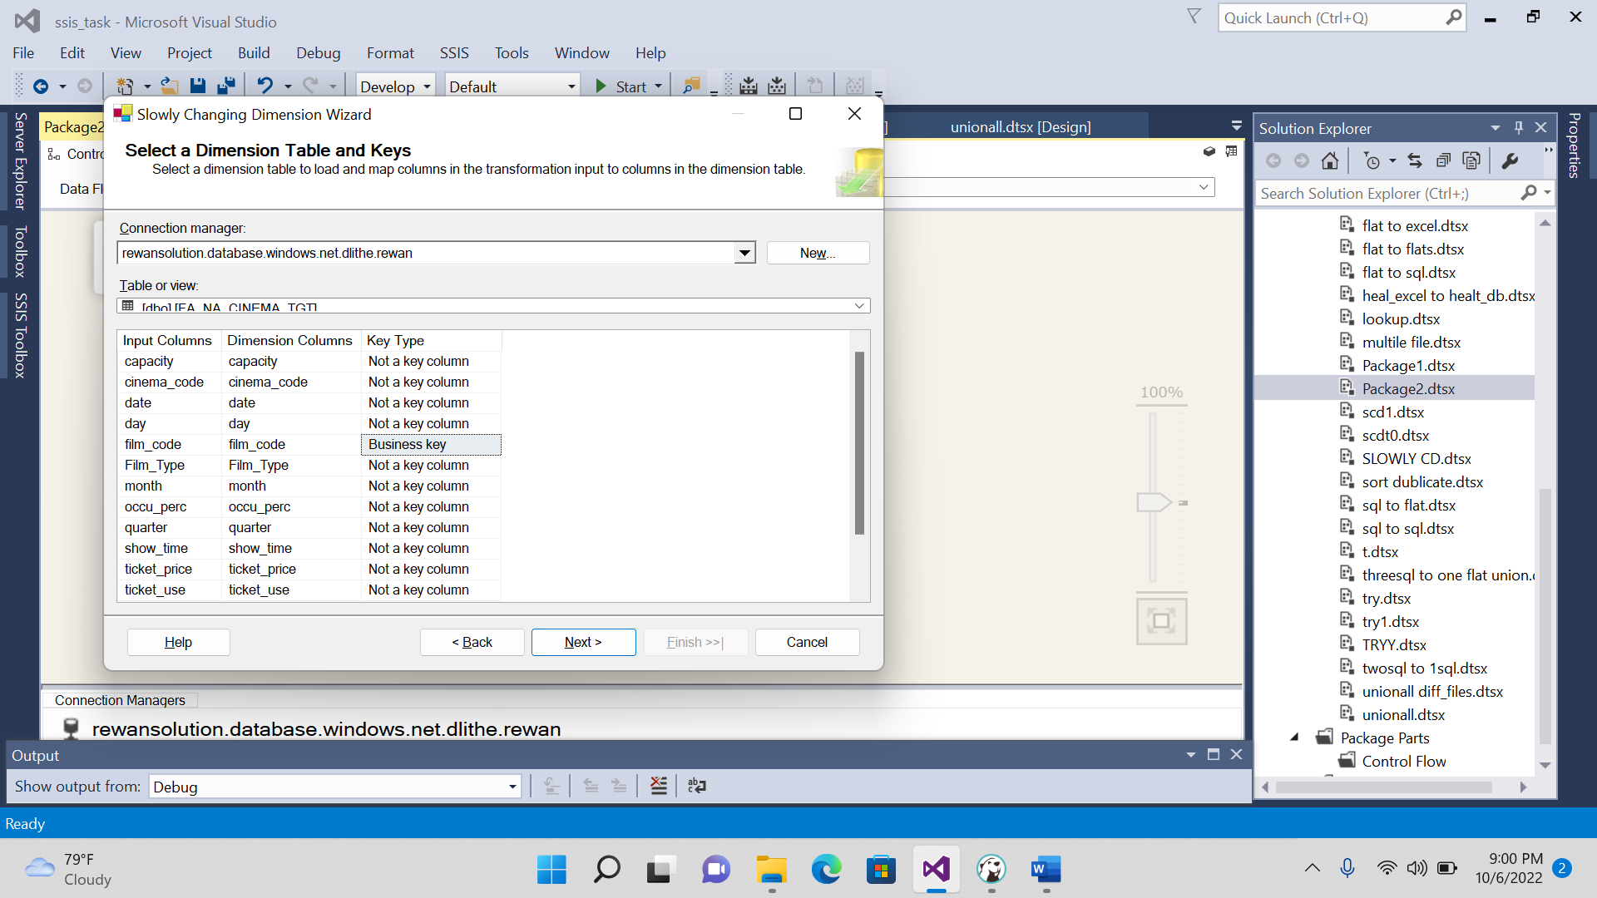

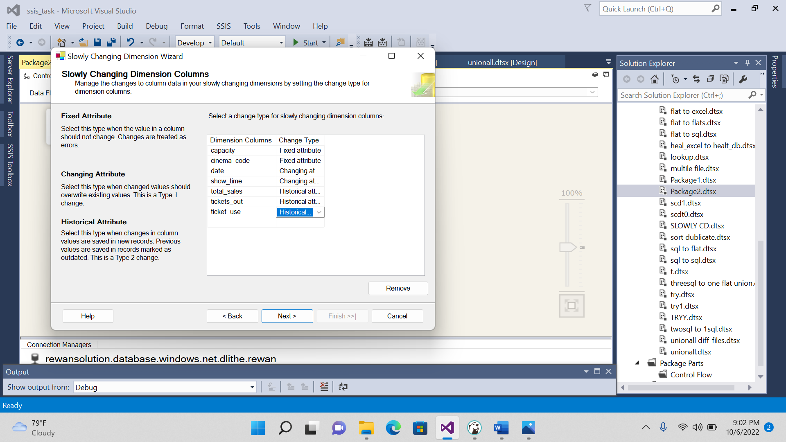

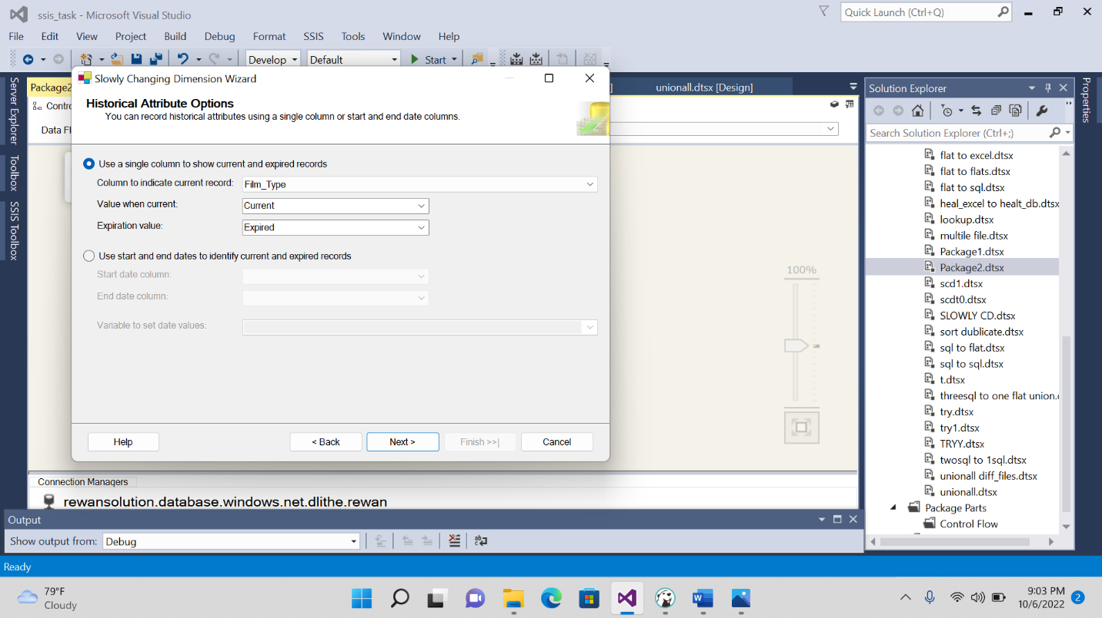

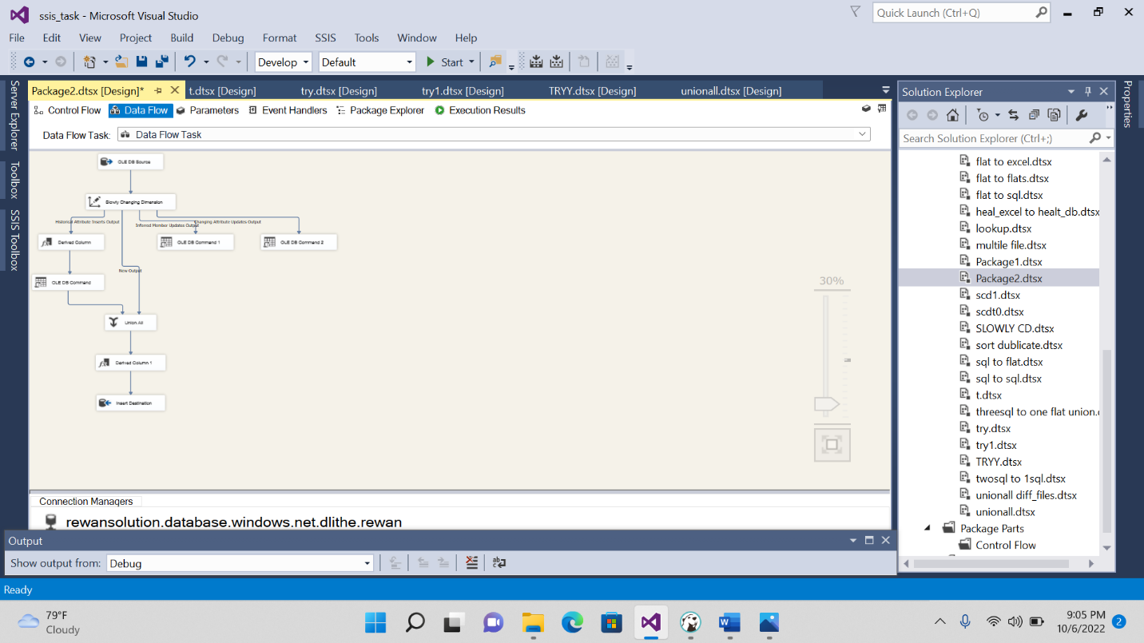

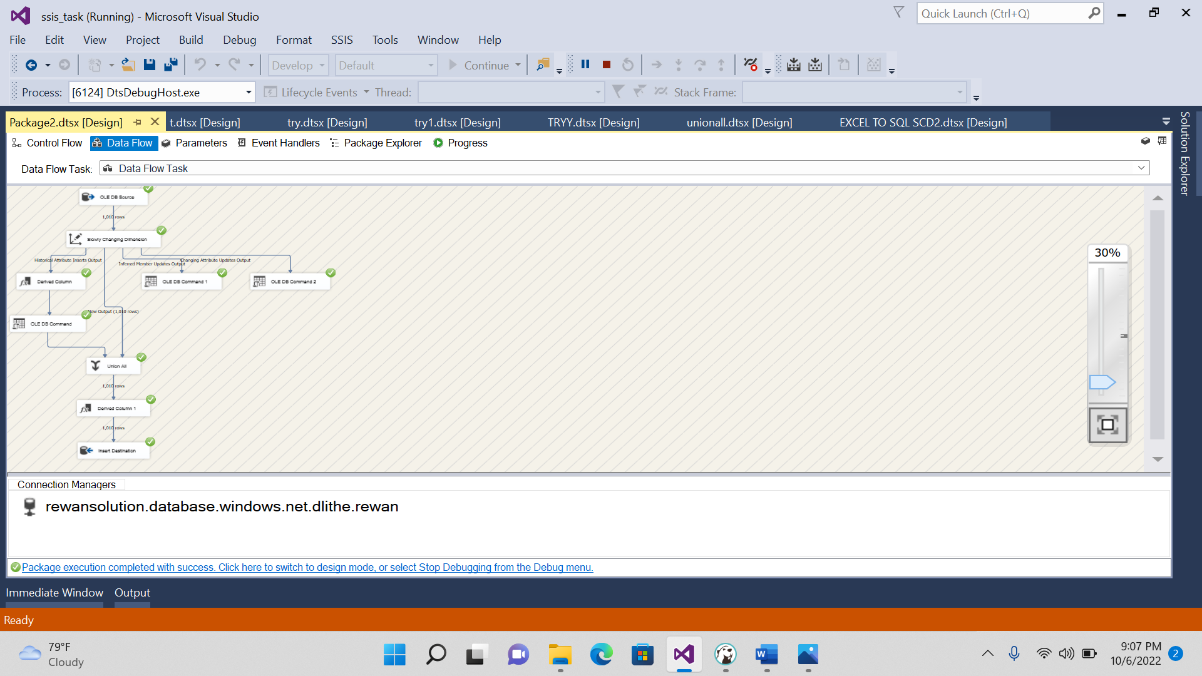

------slowly changing dimension type2---

**CREATE** **TABLE** [FA_NA_CINEMA] (

[Film_Type] **nvarchar**(255),

[film_code] **float**,

[cinema_code] **float**,

[total_sales] **float**,

[tickets_sold] **float**,

[tickets_out] **float**,

[show_time] **float**,

[occu_perc] **float**,

[ticket_price] **float**,

[ticket_use] **float**,

[capacity] **float**,

[date] **float**,

[month] **float**,

[quarter] **float**,

[day] **float**

)

**SELECT** \***FROM** [FA_NA_CINEMA]

**CREATE** **TABLE** [FA_NA_CINEMA_TGT] (

[Film_Type] **nvarchar**(255),

[film_code] **float**,

[cinema_code] **float**,

[total_sales] **float**,

[tickets_sold] **float**,

[tickets_out] **float**,

[show_time] **float**,

[occu_perc] **float**,

[ticket_price] **float**,

[ticket_use] **float**,

[capacity] **float**,

[date] **float**,

[month] **float**,

[quarter] **float**,

[day] **float**

)

**SELECT** \***FROM** [FA_NA_CINEMA_TGT]

**UPDATE** [FA_NA_CINEMA_TGT]

**SET** Film_Type='horror' **where** film_code='1492'

**UPDATE** [FA_NA_CINEMA_TGT]

**set** Film_type='romantic' **where** show_time=3

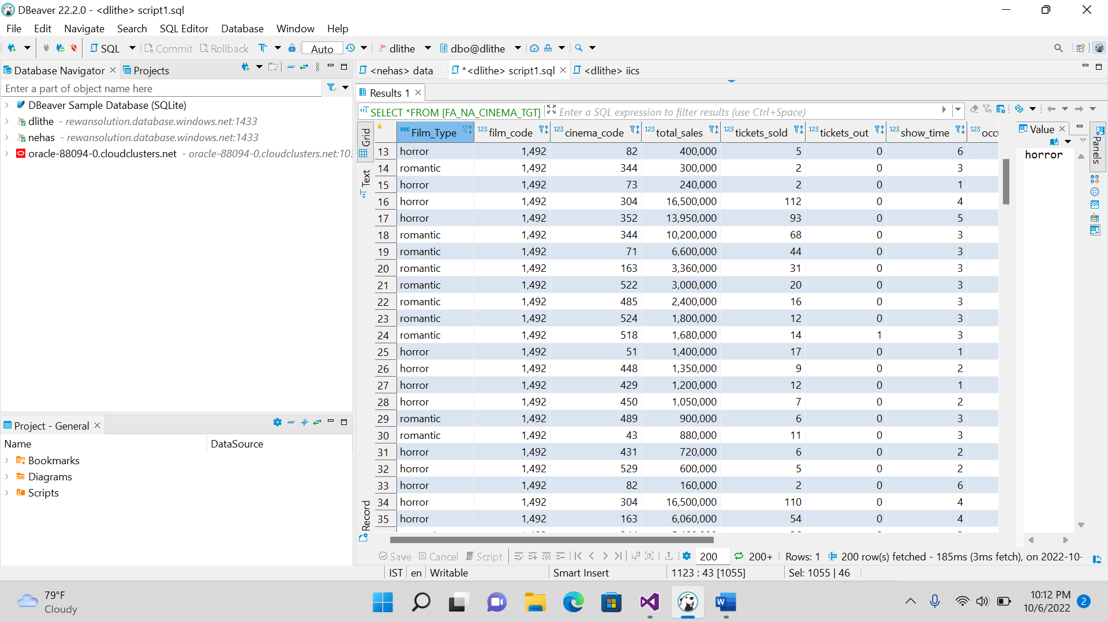

2. AGGREGATE FUNCTION IN SSIS

DATABASTE TO DATABASE:

**CREATE** **TABLE** [FA_NA_SUPPLYCHAIN_TD] (

[Type] **nvarchar**(255),

[Days for shipping (real)] **float**,

[Days for shipment (scheduled)] **float**,

[Benefit per order] **float**,

[Sales per customer] **float**,

[Delivery Status] **nvarchar**(255),

[Late_delivery_risk] **float**,

[Category Id] **float**,

[Category Name] **nvarchar**(255),

[Customer City] **nvarchar**(255),

[Customer Country] **nvarchar**(255),

[Customer Email] **nvarchar**(255),

[Customer Fname] **nvarchar**(255),

[Customer Id] **float**,

[Customer Lname] **nvarchar**(255),

[Customer Password] **nvarchar**(255),

[Customer Segment] **nvarchar**(255),

[Customer State] **nvarchar**(255),

[Customer Street] **nvarchar**(255),

[Customer Zipcode] **float**,

[Department Id] **float**,

[Department Name] **nvarchar**(255),

[Latitude] **float**,

[Longitude] **float**,

[Market] **nvarchar**(255),

[Order City] **nvarchar**(255),

[Order Country] **nvarchar**(255),

[Order Customer Id] **float**,

[order date (DateOrders)] **nvarchar**(255),

[Order Id] **float**,

[Order Item Cardprod Id] **float**,

[Order Item Discount] **float**,

[Order Item Discount Rate] **float**,

[Order Item Id] **float**,

[Order Item Product Price] **float**,

[Order Item Profit Ratio] **float**,

[Order Item Quantity] **float**,

[Sales] **float**,

[Order Item Total] **float**,

[Order Profit Per Order] **float**,

[Order Region] **nvarchar**(255),

[Order State] **nvarchar**(255),

[Order Status] **nvarchar**(255),

[Order Zipcode] **nvarchar**(255),

[Product Card Id] **float**,

[Product Category Id] **float**,

[Product Description] **nvarchar**(255),

[Product Name] **nvarchar**(255),

[Product Price] **float**,

[Product Status] **float**,

[shipping date (DateOrders)] **nvarchar**(255),

[Shipping Mode] **nvarchar**(255)

)

**SELECT** * **FROM** [FA_NA_SUPPLYCHAIN_SOURCE]

---Aggregate function----

**SELECT** * **FROM** [FA_NA_SUPPLYCHAIN_TD]

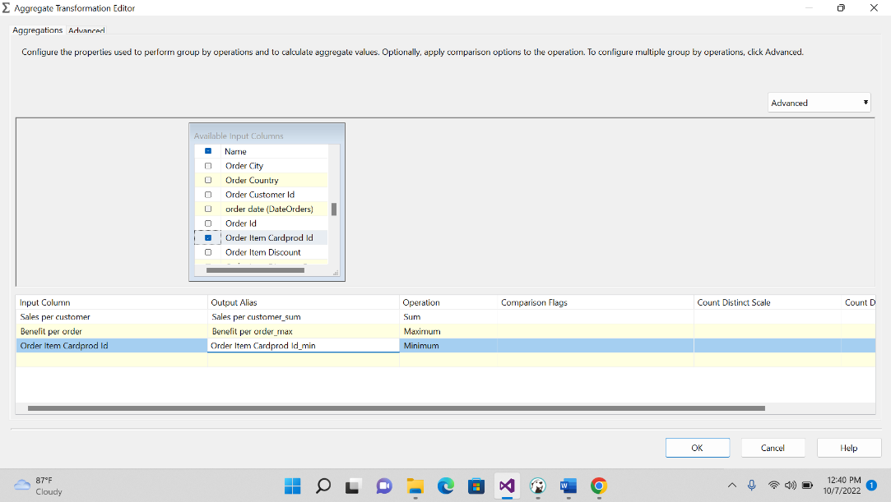

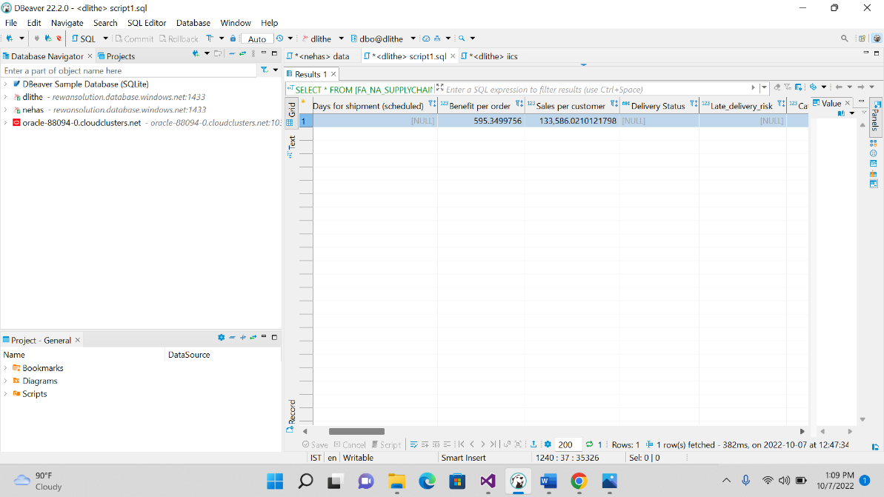

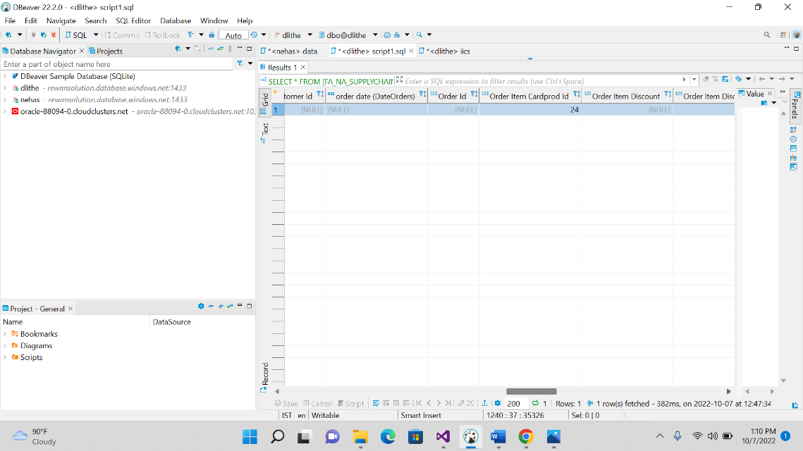

DATABASE TO FLAT FILE AGGREGATE FUNCTION:

